Network Management and Automation

Lab 6

DevOps - Ansible

University of Colorado Boulder
Network Engineering Program

Professor Levi Perigo, Ph.D.

Summary

Ansible has proved to be profoundly different from other configuration management tools available today, and is prevalent in industry for managing and configuring network devices as well as servers. It has been designed to make configurations easy in almost every way. Some of its notable features include its simple English configuration syntax, agentless running service, and its ease of setup.

Objectives

- Configuring and installing Ansible.

- Learn to use Playbooks for configuration management.

- Learn how to perform package management on the hosts.

- Learn how to perform identity and access management.

- Learn to perform file transfers and directory management.

Problem Statement
Liverpool and Real Madrid have a strong history of European Football. The two teams have once again made their way to an epic Champions League final. The FIFA administration has been entrusted the job to ensure that all things are in place to give us a thriller.
You will be acting as the FIFA administrator and be performing the tasks given below.

Objective 1 – Setting up a Virtual Network

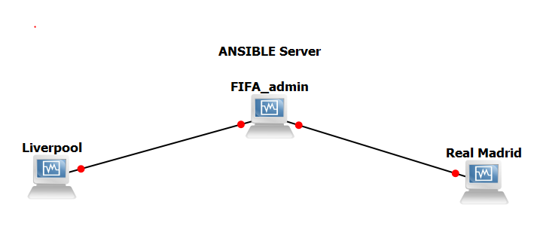
Figure 1
- Create the above network of three virtual machines (use the NetMan VM as the FIFA_admin, which will act as the Ansible Server) in VMWare Workstation.

You can use any Linux based OS of your choice to spawn the Liverpool and Real Madrid virtual machines.
OR

Please use the following link to download the Ubuntu 64-bit VM for spinning liverpool and realmadrid hosts in the virtual network.

https://drive.google.com/drive/folders/1jGv62-twU3q5UrZF_O3IjUw7GTil_6FL?usp=sharing

Instructions:

-Right click on ‘VMware virtual machine configuration (.vmx)’ and select ‘open with VMWare workstation’ for both the VMs.
usename:password => netman:netman
-In NetMan, Liverpool and Real Madrid VMs, all network configurations are done in ‘/etc/network/interfaces’ already.
-Bring up 2 additional custom network adapters in NetMan VM. One custom network adapter is already configured in Liverpool and Real Madrid VM.

PS:
There is a typo in NetMan VM’s network configuration:
In /etc/network/interfaces, instead of
‘# interfaces eth2 and eth3 are to be used for lab-9’, it should be ‘for lab-6’
- Make sure network adapters are configured as below:
Liverpool Internal Network- liverpool-192.168.10.1 and netman-192.168.10.2
Realmadrid Internal Network - realmadrid-172.16.10.1 and netman-172.16.10.2

Provide screenshots of successful network connectivity (ping between netman and Liverpool, and netman and realmadrid). [10 Points]
Ping from Netman to Liverpool and viceversa:
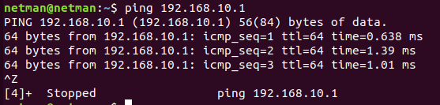
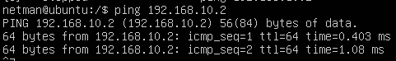

Ping from Netman to RealMadrid and viceversa:
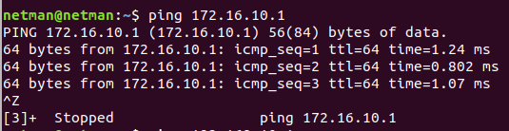
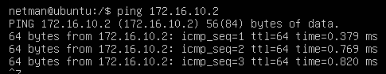

Objective 2 – Installing Ansible

- Issue the “ansible --version” command to check if ansible is present in FIFA_admin. If not, install it using pip3. Provide screenshot of the output. [5 Points]

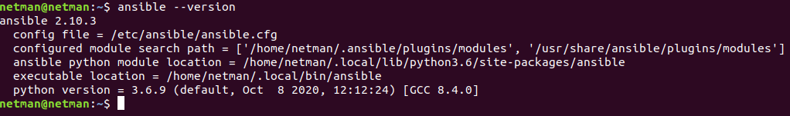

- In order to allow FIFA_admin to control the two hosts through a playbook, ensure that you add the hosts in the /etc/ansible/hosts or any other Inventory file of your choice (http://docs.ansible.com/ansible/intro_inventory.html). Ensure connectivity between the server and managed hosts using the “ansible all -m ping --ask-pass” command. Provide screenshot of the output. [5 Points]

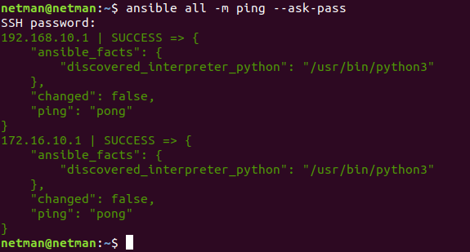
Objective 3 – Creating a Centralized Playbook

The following objectives need to be accomplished by creating a single playbook on the FIFA_admin machine. The playbook file should be named as “YourIdentiKey_play.yml”. Make sure you give meaningful names to the tasks performing the below objectives in the playbook.

Objective 3.1 – Installing Packages

- Liverpool and Real Madrid machines should have FTP and HTTP capabilities. Additionally they need pip and expect packages. Install all these essential packages through the playbook on FIFA_admin (use loops to perform the repetitive installation tasks).
[10 Points]

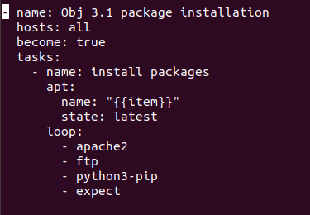

- Provide screenshots of the relevant portion of the playbook and the successful package installation on the two nodes. [10 Points]

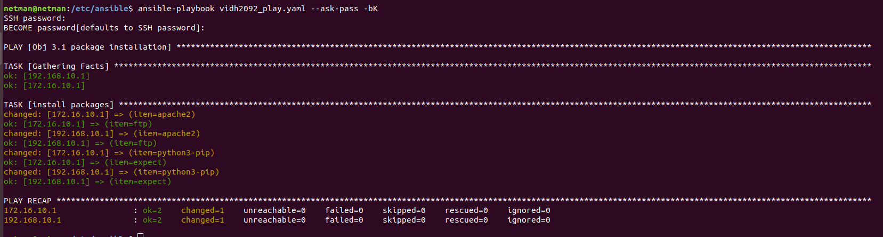
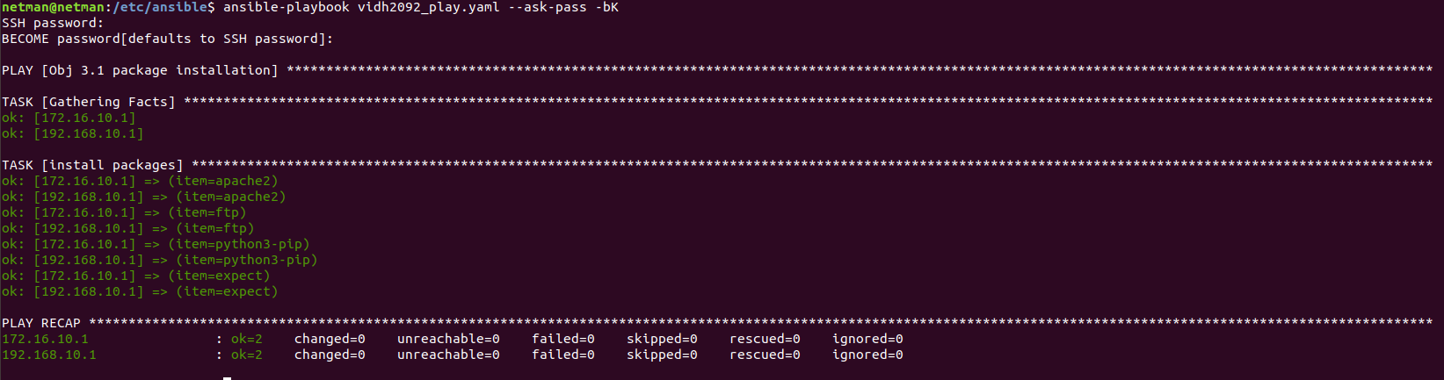

Objective 3.2 – Creating Users, Groups, and Permissions

- Create users and groups on the managed hosts using the same playbook on the control machine. [5 Points]

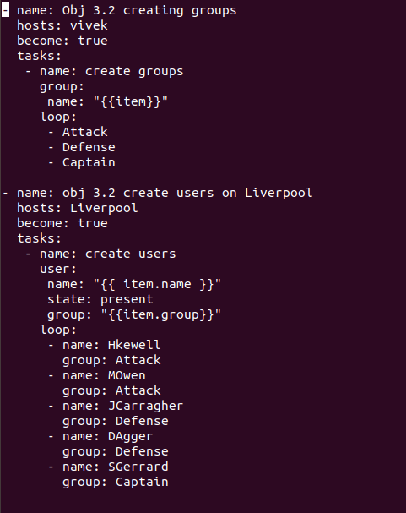

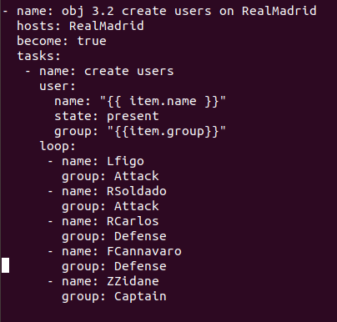

- The three groups on each machine are: Attack, Defense, and Captain. The users to be created, their corresponding groups, and permissions are mentioned in tables below. The users should be created with the naming format of FirstInitialLastName (for example Harry Kewell’s user name would be hkewell). [15 Points]
Liverpool

User | Group/Groups | Group Permissions
Harry Kewell | Attack | rw-rw-rw
Michael Owen | Attack | rw-rw-rw
Jamie Carragher | Defense | --x--x--x
Daniel Agger | Defense | --x--x--x
Steven Gerrard (present in two groups) | Captain and Any group with highest access permissions (Eg: Wheel) | rwxrwxrwx

Real Madrid

User | Group/Groups | Group Permissions
Luis Figo | Attack | rw-rw-rw
Roberto Soldado | Attack | rw-rw-rw
Roberto Carlos | Defense | --x--x--x
Fabio Cannavaro | Defense | --x--x--x
Zinedine Zidane  (present in two groups) | Captain and Any group with highest access permissions (Eg: Wheel) | rwxrwxrwx

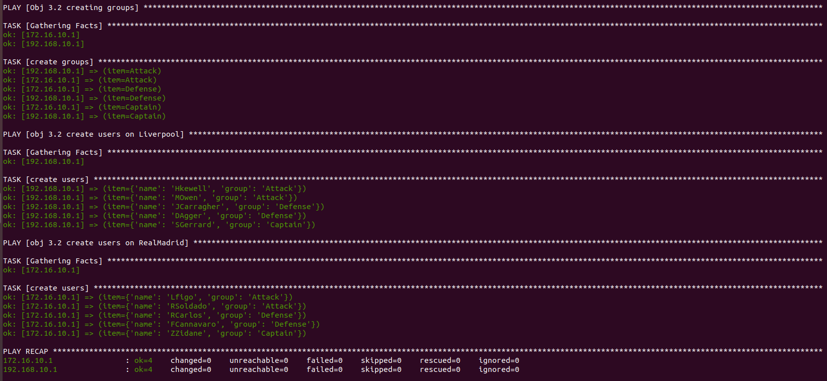
- Provide screenshots of the relevant portion of the playbook, successful creation of all users and their group permissions. [5 Points]

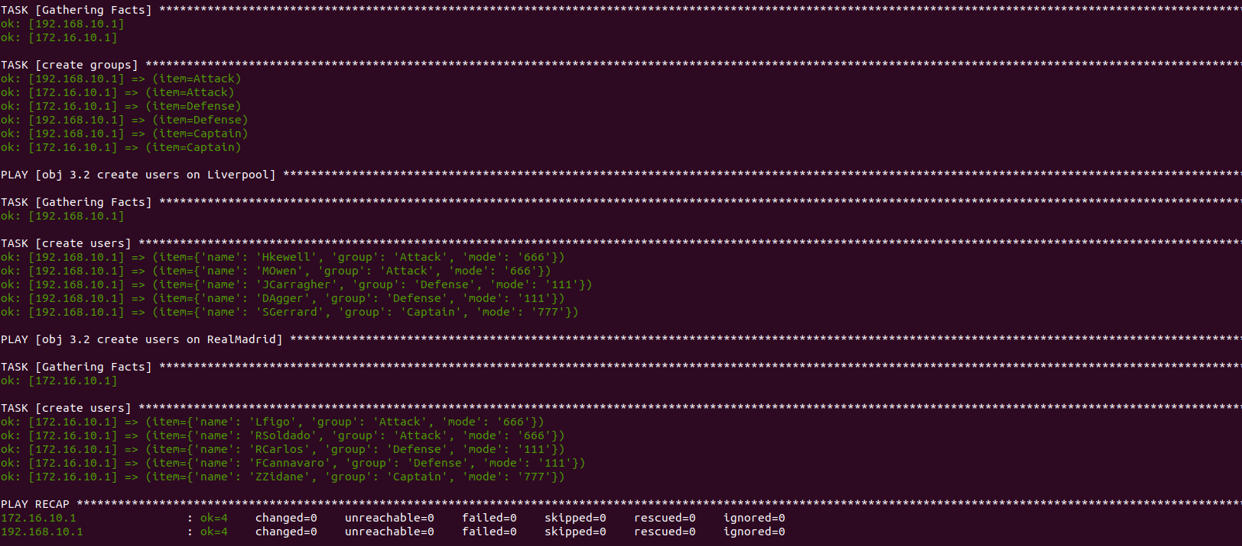
Users (Liverpool):
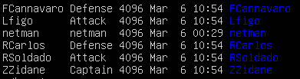

Users (RealMadrid):

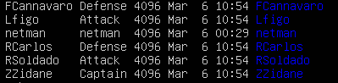

Objective 3.3 – Creating Files and Directories

- Add commands to the same playbook to create directories on Liverpool and Real Madrid which will be used to store route table information in the next objective. The directory should be created in the path /MachineName_Admin/Route_Info/. The owner and group owner for this directory should be Captain, and they should have all permissions. Users who are not in the Captain group should have read-only access to this directory.

- Provide screenshots of the relevant portion of the playbook, successful creation of the directory and applied permissions. [10 Points]

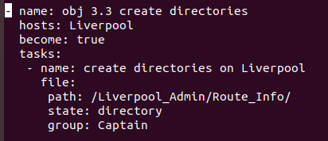

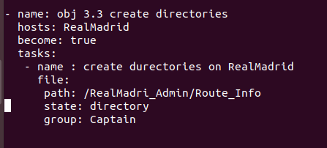

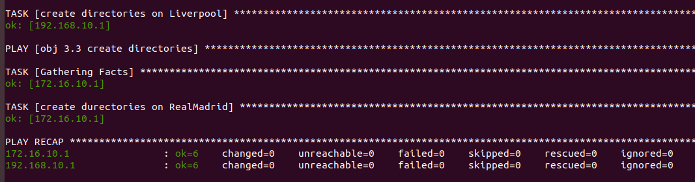

- On each host, create a file Captain_Details.txt under the above created directory and store the captain information (full name, nationality, username) using the same playbook. Provide relevant screenshots. [10 Points]

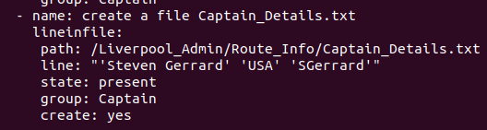

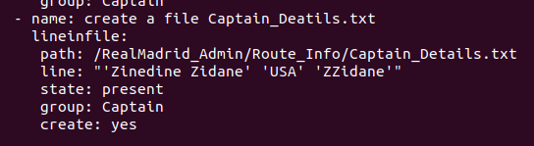

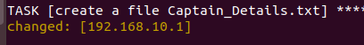

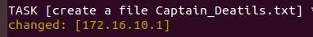

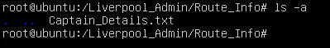

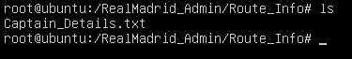

Objective 3.4 – Executing Shell Commands, Performing File Transfer

- The FIFA_admin machine needs to request route table and top ten running processes (based on memory usage) from the managed hosts. Add functionality in the playbook to do the following:
- Execute shell commands (hint: netsat , ps ) to retrieve the required information and store it in two different files. [10 Points]

Running process and routing table from the hosts:
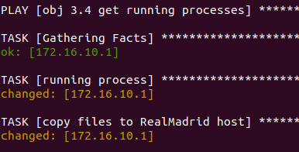

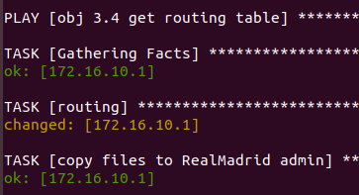

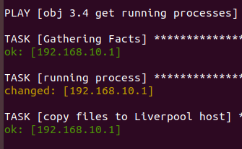

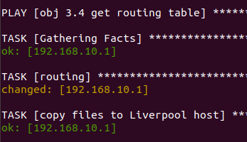

Process1 and process3 are the files stored on hosts (Liverpool):
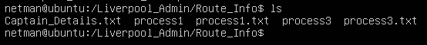

Process2 and process4 are the files stored on hosts (RealMadrid):

- Perform secure transfer of these files from host to FIFA_admin using SCP commands. Use the expect module to enter password and any other information associated with SCP when prompted. Passwords and prompts should not be handled manually but through the playbook. [15 Points]
Yaml for scp file transfer using expect , similarly it was done for all the files:
Using expect. I also added (.*) before password. I used expect, It acts like regex and is literally responding to any prompts with the word "password" and will respond with "netman".
Secure transfer of files from both the hosts to netman VM:

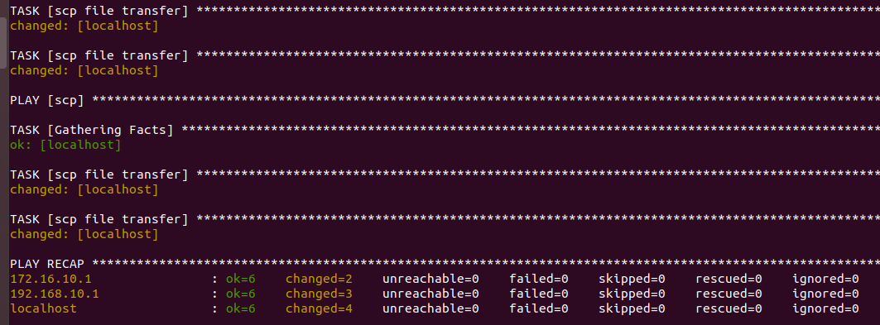

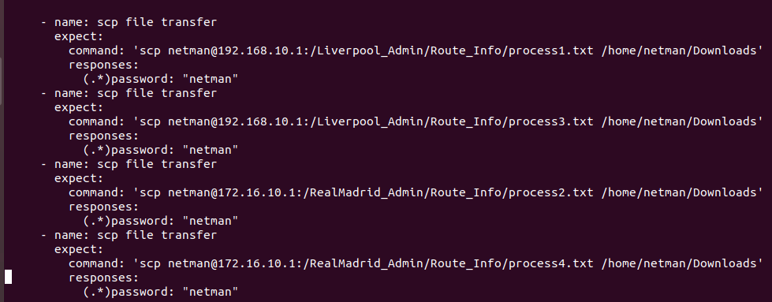

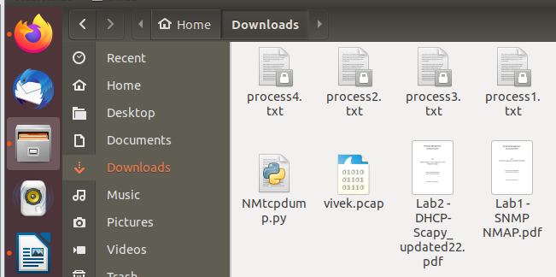

- Provide screenshots of the relevant portion of the playbook and successful file transfer.
[5 Points]
Successful file transfer to FIFA admin (netman VM): Process1, process2, process3, process4.

Objective 3.5 – Combining multiple files into a single file

- Manually generate SSH keys for the following players on their local machines: [5 Points]
  - Liverpool b. Real Madrid
Michael Owen Luis Figo
Daniel Agger Fabio Cannavaro
Steven Gerrard Zinedine Zidane

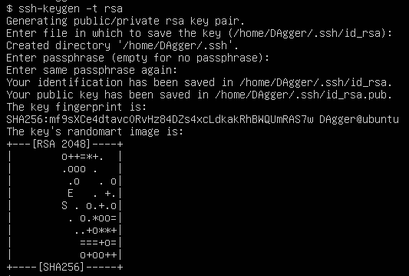

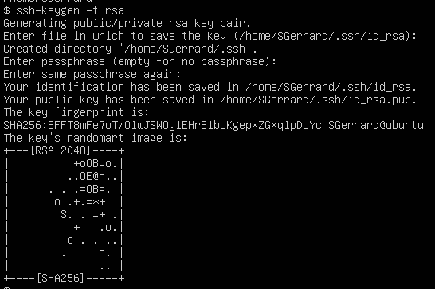

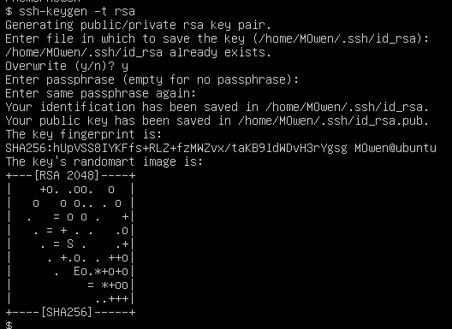

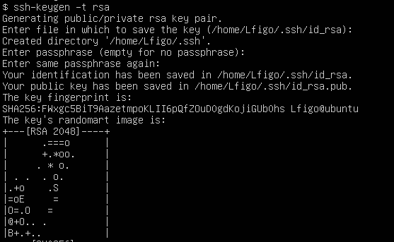

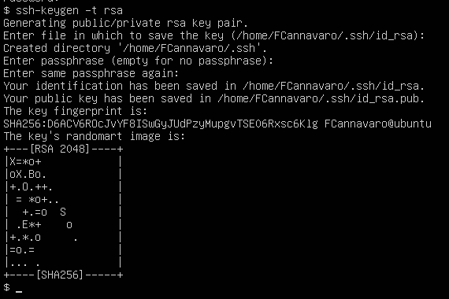

2.In the same playbook, use the assemble module of Ansible to combine the public keys( .pub) for the above players into a single file on the host machine named as TeamName_authorizedKeys.txt and store the file in the .ssh directory of the root user. (eg. Liverpool_authorizedKeys.txt will have public keys of the three Liverpool players and will be stored in the root user’s .ssh directory on the Liverpool machine.)
[10 Points]

getting the ssh keys for all 3 users on Liverpool and storing it one file Liverpool_authorizedkeys.txt:

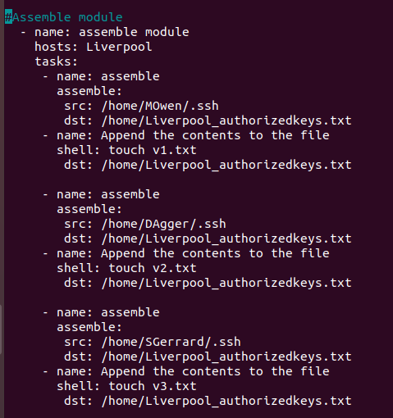

getting the ssh keys for all 3 users on RealMadrid and storing it one file RealMadrid_authorizedkeys.txt:

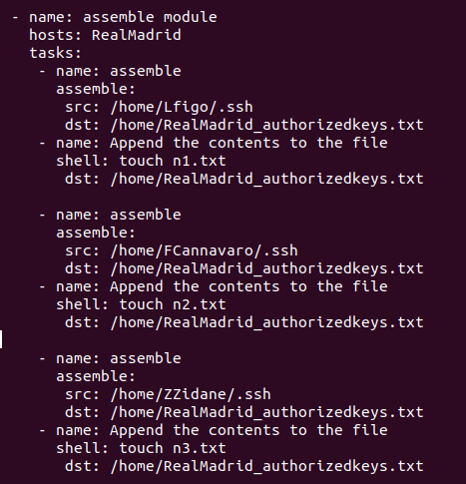

SCP file transfer from liverpool to netman:

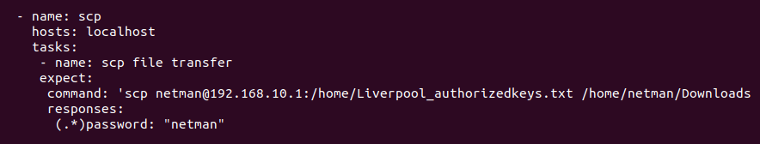
SCP file transfer from RealMadrid to netman:

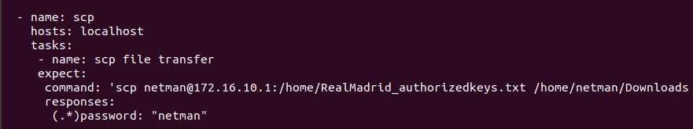

- Using the playbook, send these files to the FIFA_admin machine and store them in the root user’s .ssh directory. [10 Points]
File transfer from Liverpool and RealMadrid to netman.

- Provide screenshots of the relevant portion of the playbook and the files in the .ssh directory of the root user of FIFA_admin machine. [5 Points]

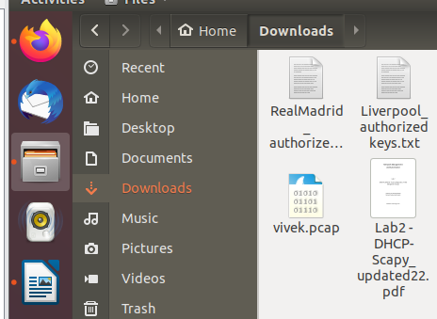

Objective 4 – Extra Credit - Ansible Additional Server Configuration and Router Configurations

Part 1 (Using additional modules in Ansible)

- Create two more playbooks named as LiverpoolManager.yml and RealMadridManager.yml

- Think of a use case that will make use of the following Ansible modules in the respective YAML files: [10 Points]

File | Modules to use
LiverpoolManager.yml | group_by, wait_for, set_fact
RealMadridManager.yml | template

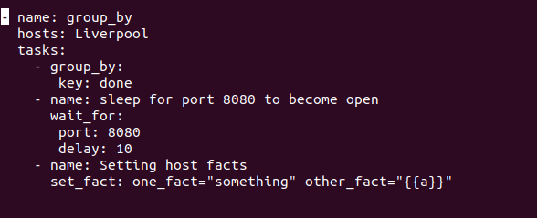
Liverpool modules (GROUP_BY, WAIT_FOR, SET_FACT):
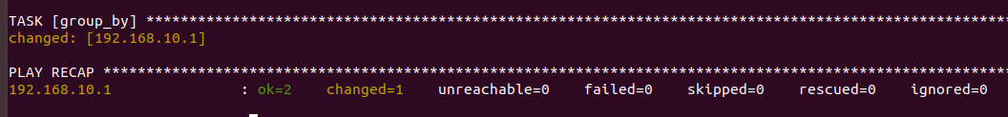

RealMadrid (Template):

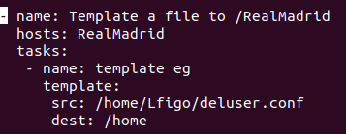

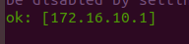

- Once you are done executing the above YAML files separately, think of executing all the above tasks via a single playbook that you created for this lab (YourIdentikey_play.yml)
[5 Points]

Part 2 (Router configuration via Ansible)

- Construct the same topology done in Automation 1 and configure IBGP between the routers by passing commands through Ansible playbook. It is not required to use multithreading in this case. [15 Points]

GNS3:

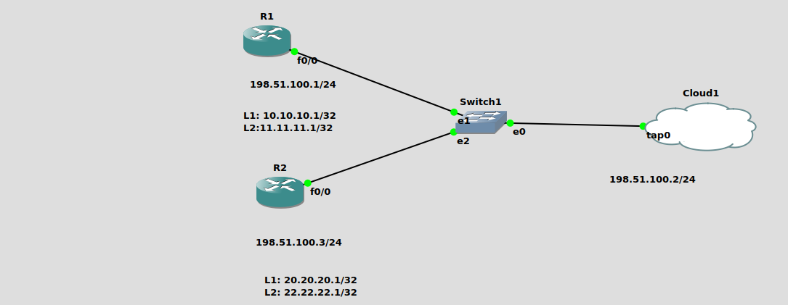
Code:

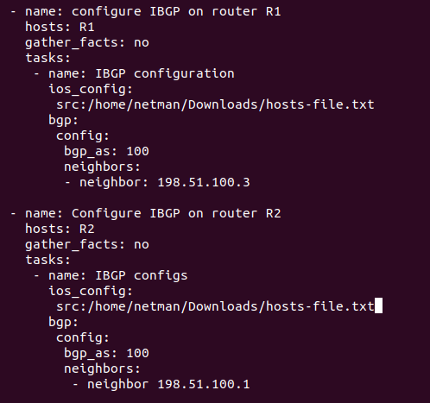

Config on R1:

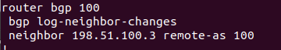

Config on R2:

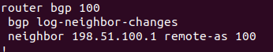

Total Points ____________ / 175

